LAB5: Baseband Signal Transmission II

Ⅰ.

***Task1:***

Ⅰ. Task 1

Consider 4ASK modulation. The signals are:



and



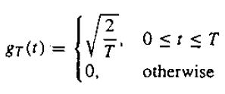,

where *d*=1, *T*=1, fc=5Hz, the mapping rule from the bit pair to *m* is: 00->1, 01->2,11->3,10->4.

(1) If the message bits are 11 00 10 00 01, plot the corresponding 4ASK signal in both time and frequency domain, sampling frequency fs=1000Hz.

(2) Give the average signal energy per bit, i.e., Eb, for 4ASK.

(3) Denote SNR as Eb/N0, plot the theoretical SER (symbol error rate) and simulated SER, for SNR=0:2:8 dB.

Hint: refer to the slides and codes related to 4PAM baseband signal in Ch5 ppt.

***Code***:

**LAB6_1.m**

% MATLAB script for Illustrated Problem 6.1

%inital the parameters

T=1; %Symbol exzisting time

delta_T=T/1000; % sampling interval

fc=5/T; % carrier frequency

M=4;

d=1;

% 11 00 10 00 01

Sym=[3, 1, 4, 1, 2];

A_m=(2*Sym-1-M)*d; % amplitude

t=[0:delta_T:length(Sym)-delta_T]; % time axis

N=length(t);

g_T=sqrt(2/T)*ones(1,N);

for i=1:N

for j=1:length(Sym)

if(t(i)<j)

u_m(i)=A_m(j)*g_T(i)*cos(2*pi*fc*t(i));

break;

end

end

end;

[sf,U_m]=T2F(t,u_m);

% Plotting commands follow.

figure(1);

plot(t,u_m);

figure(2);

plot(sf,abs(U_m));

SNRindB1=0:2:8; %SNR for bit

SNRindB2=0:0.1:8;

for i=1:length(SNRindB1),

% simulated error rate

smld_err_prb(i)=ASK4_symerr(SNRindB1(i)); % simulated bit and symbol error rates

end;

for i=1:length(SNRindB2),

% signal-to-noise ratio

SNR_per_bit=exp(SNRindB2(i)*log(10)/10);

% theoretical error rate

theo_err_prb(i)=(3/2)*Qfunct(sqrt((4/5)*SNR_per_bit)); % theoretical Symbol-error rate

end;

% Plotting commands follow.

figure(3)

semilogy(SNRindB1,smld_err_prb,'*');

hold

semilogy(SNRindB2,theo_err_prb);

**ASK4_symerr.m**

function [p]=ASK4_symerr(snr_in_dB)

% [0p0]=ASK4_symerr(snr_in_dB)

% 0simulates the probability of error for the given

%0 snr_in_dB, signal to noise ratio in dB.

d=1;

SNR=exp(snr_in_dB*log(10)/10); % signal to noise ratio per bit

sgma=sqrt(5/SNR)/2; % sigma, standard deviation of noise

N=10000; % number of symbols being simulated

% generation of the quarternary data source follows

for i=1:N,

temp=rand; % a uniform random variable over (0,1)

if (temp<0.25),

dsource(i)=1; % with probability 1/4, source output is "00"

elseif (temp<0.5),

dsource(i)=2; % with probability 1/4, source output is "01"

elseif (temp<0.75),

dsource(i)=3; % with probability 1/4, source output is "10"

else

dsource(i)=4; % with probability 1/4, source output is "11"

end

end;

% detection, and probability of error calculation

numoferr=0;

for i=1:N

% The matched filter outputs

if (dsource(i)==1),

r=-3*d+gngauss(sgma); % if the source output is "00"

elseif (dsource(i)==2),

r=-d+gngauss(sgma); % if the source output is "01"

elseif (dsource(i)==3)

r=d+gngauss(sgma); % if the source output is "10"

else

r=3*d+gngauss(sgma); % if the source output is "11"

end;

% detector follows

if (r<-2*d),

decis=1; % decision is "00"

elseif (r<0),

decis=2; % decision is "01"

elseif (r<2*d),

decis=3; % decision is "10"

else

decis=4; % decision is "11"

end;

if (decis~=dsource(i)), % if it is an error, increase the error counter

numoferr=numoferr+1;

end;

end

p=numoferr/N; % probability of error estimate

end

***Output:*** Fig.1&Fig.2&Fig.3

***Discussion:***

1. mapping rule from the bit pair to *m* is: 00->1, 01->2,11->3,10->4.

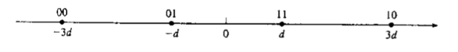

message bits are 11 00 10 00 01 mapping:

(d -3d 3d -3d d) $\sqrt{\frac{2}{T}}$

*

The time domain and frequency of the message is in Fig.1&Fig.2

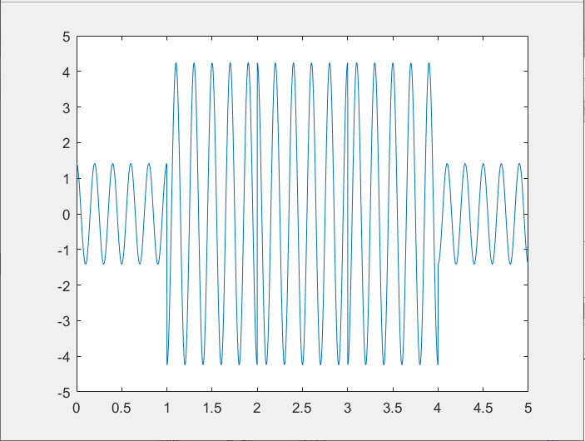

Fig.1 the message signal

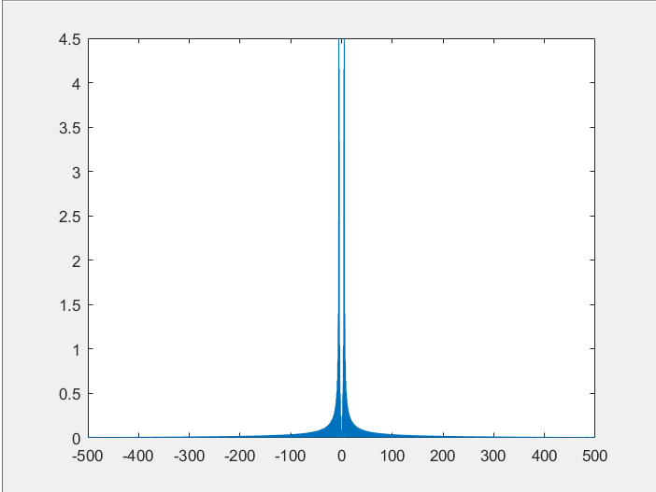

Fig.2 the message signal in frequency domain

average energy per symbol is $\left\{\begin{aligned}E_{av}=\frac{1}{4}\sum_{k=1}^{4}{\int_{0}^{T}{{s_{k}(t)}^{2}dt}}=\frac{1}{4}\sum_{k=1}^{4}{{A_{m}}^{2}\int_{0}^{T}{{φ(t)}^{2}dt}} \\ \int_{0}^{T}{{φ(t)}^{2}dt}=1 \\ A_{m}=\left(2*m-1-M\right)=2*m-5, m=1、2、3、4\end{aligned}\right.$

$$So, E_{av}=\frac{1}{4}*\left(9+1+1+9\right)=5$$

$E_{av}$ is the energy for Symbol

average energy per bit is $E_{b}=\frac{E_{av}}{\log_{2}{4}}=\frac{5}{2}$

Theoretical SER (symbol error rate) :

ASK is the modulation of PAM signal, they use the same formula.

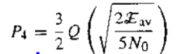

simulated SER (symbol error rate) :

I use the **ASK4_symerr.m** to simulate. The most import detail is that SNR is denoted as Eb/N0.

The Noise variance: N0/2

SNR: Eb/N

gngauss(sgma):sgma is the mean of the variance

From (2),we know 4ASK has an energy of 5 per symbol, and each symbol has 2 bits, so Eb equals 2.5.Connected the SNR，we get the value of sgma.

sgma=sqrt(5/SNR)/2;

With the Analysis above, Fig.3 is plotted.

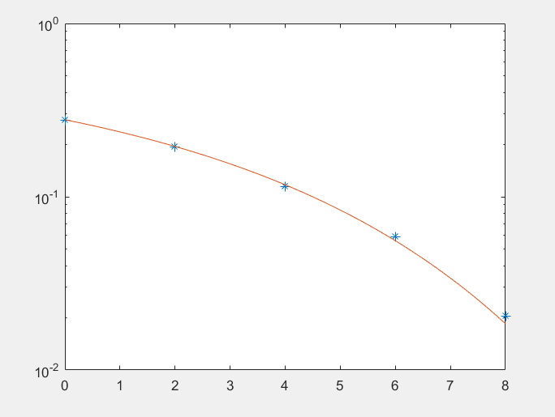

Fig.3 theoretical and simulated symbol error rate

II.

***Task2:***

Consider the 4PSK modulation. The signals are:

$$u_{m}\left(t\right)=\sqrt{\frac{2E_{S}}{T}}\cos\left(2πf_{c}t+\frac{2πm}{4}+\frac{π}{4}\right),m=0,1,2,3$$

where **the average signal energy** **Es=1**, T=1, fc=5Hz, and the constellation diagram is:

 

(1) If the message bits are 11 00 10 00 01, plot the corresponding 4PSK signal in both time and frequency domain, sampling frequency fs=1000Hz.

(2) Plot the constellation diagram of the 4PSK experiencing the AWGN channel with N0=0.5. (You can generate a large number of 4PSK signals and noise samples.)

(3) Give the BER and SER for N0=0.5, from theoretical calculation and numerical simulation, respectively.

***Code***:

**LAB6_2.m**

% MATLAB script for Illustrated Problem 6.2

%inital the parameters

T=1;

Es=1;

M=4;

fc=5/T; % carrier frequency

N=1000; % number of samples

delta_T=T/N;

% 11 00 10 00 01

Sym=[3, 1, 4, 1, 2];

Ut=0:delta_T:T-delta_T;

u0=sqrt(2*Es/T)*cos(2*pi*fc*Ut+pi/4);

u1=sqrt(2*Es/T)*cos(2*pi*fc*Ut+2*pi/M+pi/4);

u2=sqrt(2*Es/T)*cos(2*pi*fc*Ut+4*pi/M+pi/4);

u3=sqrt(2*Es/T)*cos(2*pi*fc*Ut+6*pi/M+pi/4);

t=0:delta_T:5-delta_T;

u=[u2,u0,u3,u0,u1];

[sf,U]=T2F(t,u);

% Plotting commands follow.

figure(1);

plot(t,u);

figure(2);

plot(sf,abs(U));

N0=0.5;

SNR=Es/N0 ;

SNRindB=10*log10(SNR);

sgma=sqrt(N0/2);

N=10000;

s00=[1 1 ]/sqrt(2);

s01=[-1 1]/sqrt(2);

s11=[-1 -1]/sqrt(2);

s10=[1 -1]/sqrt(2);

% generation of the data source

for i=1:N,

temp=rand; % a uniform random variable between 0 and 1

if (temp<0.25), % With probability 1/4, source output is "00."

dsource1(i)=0;

dsource2(i)=0;

elseif (temp<0.5), % With probability 1/4, source output is "01."

dsource1(i)=0;

dsource2(i)=1;

elseif (temp<0.75), % With probability 1/4, source output is "10."

dsource1(i)=1;

dsource2(i)=0;

else % With probability 1/4, source output is "11."

dsource1(i)=1;

dsource2(i)=1;

end;

end;

% detection and the probability of error calculation

numofsymbolerror=0;

numofbiterror=0;

figure(3);

for i=1:N,

% The received signal at the detector, for the ith symbol, is:

n(1)=gngauss(sgma);

n(2)=gngauss(sgma);

if ((dsource1(i)==0) & (dsource2(i)==0)),

r=s00+n;

plot(r(1),r(2),'b.'); %plot the constellation diagram

hold on

elseif ((dsource1(i)==0) & (dsource2(i)==1)),

r=s01+n;

plot(r(1),r(2),'go');

hold on

elseif ((dsource1(i)==1) & (dsource2(i)==0)),

r=s10+n;

plot(r(1),r(2),'rx');

hold on

else

r=s11+n;

plot(r(1),r(2),'c+');

hold on

end;

% The correlation metrics are computed below.

c00=dot(r,s00);

c01=dot(r,s01);

c10=dot(r,s10);

c11=dot(r,s11);

% The decision on the ith symbol is made next.

c_max=max([c00 c01 c10 c11]);

if (c00==c_max),

decis1=0; decis2=0;

elseif (c01==c_max),

decis1=0; decis2=1;

elseif (c10==c_max),

decis1=1; decis2=0;

else

decis1=1; decis2=1;

end;

% Increment the error counter, if the decision is not correct.

symbolerror=0;

if (decis1~=dsource1(i)),

numofbiterror=numofbiterror+1;

symbolerror=1;

end;

if (decis2~=dsource2(i)),

numofbiterror=numofbiterror+1;

symbolerror=1;

end;

if (symbolerror==1),

numofsymbolerror = numofsymbolerror+1;

end;

end;

%simulated bit and symbol error rates

pb=numofbiterror/(2*N) % since 2N bits are transmitted

ps=numofsymbolerror/N % since there are totally N symbols

%error bit and symbol error rates

theo_err_prb=Qfunct(sqrt(SNR)) % theoretical bit-error rate

theo_err_sym=theo_err_prb*2

Output: Fig.4&Fig.5&Fig.6

***Discussion:***

In this task, I plot the PSK signal.

The The signals follow the formula below:



The Fig below carries the more visualized view of PSK.

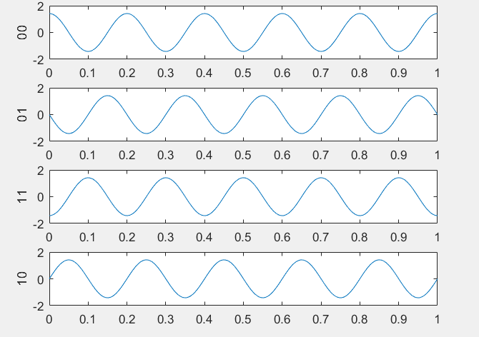

In these four curves, they have the same wave while the phases are different. Compared with result in Fig.4, we can easily find the phase deflection at the end of the Symbol (like t=1,2,3and 4).

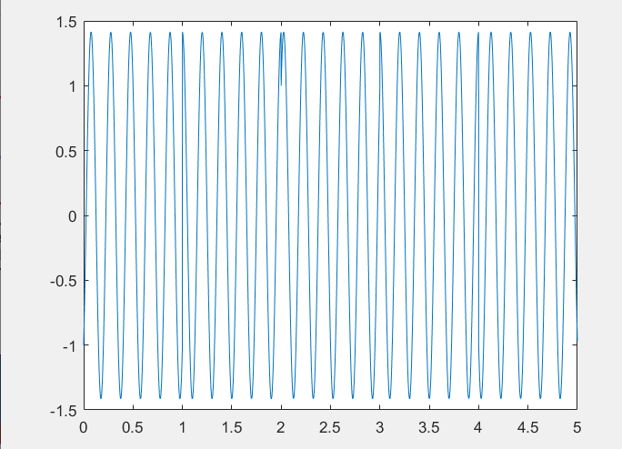

Fig.4 the time domain of 4PSK signal

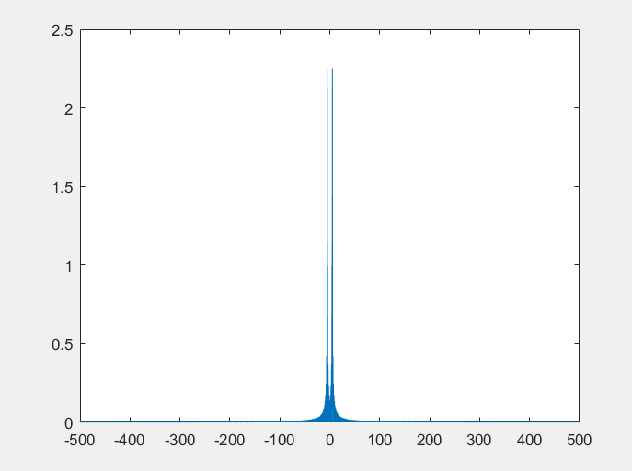

Fig.5 the Spectrum of 4FSK signal

1. In this task, the expression of the constellation diagram is essential.

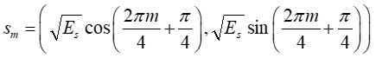

In this task, $E_{S}=1$,range m=0:1:3. We can get four points.

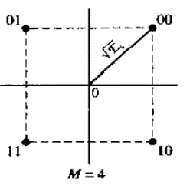Like this, $\left\{\begin{aligned}{00→(\frac{\sqrt{2}}{2},-\frac{\sqrt{2}}{2}) \atop 01→(-\frac{\sqrt{2}}{2},\frac{\sqrt{2}}{2})} \\ {11→(-\frac{\sqrt{2}}{2},-\frac{\sqrt{2}}{2} \atop 10→(\frac{\sqrt{2}}{2},-\frac{\sqrt{2}}{2}}\end{aligned}\right.$

In Fig.6., I use points with different color and shape to plot them.

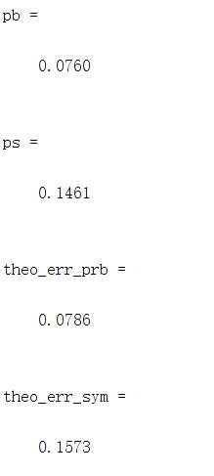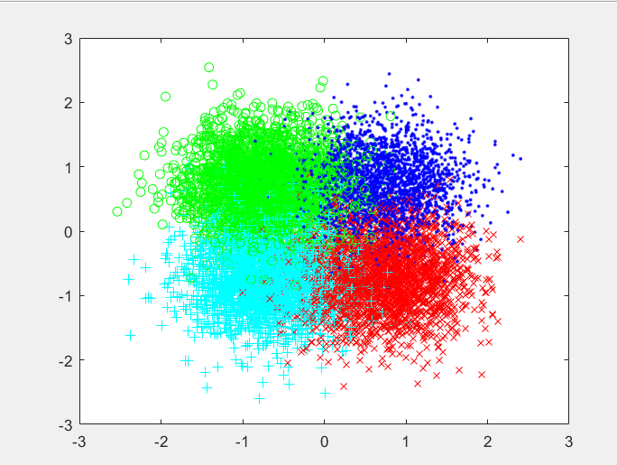

Fig.6 the constellation diagram of the 4PSK

1. 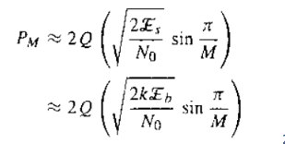It is easy to get the SNR = $\frac{E_{S}}{N_{0}}=2$. In 4FSK signal，each symbol has 2 bits.

So ENR= 1.

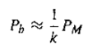 The symbol error rate and the bit error rate satisfy the formula right. In this task, we can easily get the $P_{M}$ with the formula upward. Then , inP4ASK, $P_{M}=2*P_{b}$.

At the rightmost, we see the

four data which verifies the correct

line of our theory.